Lab Assignment Report
React Movie Watch List Application
Web Development Course

Student Information
Student Name | Michael Maged Fawzy
Student ID | 22P0005

Repository
GitHub Username | https://github.com/Michael-Maged/IP-Labs

Project Overview
This lab assignment involved building a React-based Movie Watch List application. The application allows users to track movies they have watched, rate them using a star system (0–5 stars), and add personal review comments. The interface is built as a single-page application using React hooks for state management.

Implemented Features
- Add a new movie with title, star rating (0–5), and optional review comment
- Display a live list of all added movies with their ratings and comments
- Star rendering using emoji (⭐) mapped from the numeric rating value
- Inline editing: update the rating via dropdown and review via textarea per card
- Delete individual movies using the remove (✕) button
- Empty state message when the watch list contains no movies
- Live movie count displayed in the section header

Technical Implementation
The application is implemented as a functional React component using the useState hook to manage the movies array and the controlled input fields (movieTitle, rating, comment). Each movie is stored as an object with an auto-generated id (Date.now()), title, numeric rating, and comment string. The updateMovie helper spreads existing properties and applies partial updates, enabling real-time inline editing without re-mounting the card components.

Screenshots
Screenshot 1 – Application Initial State (Empty Watch List)
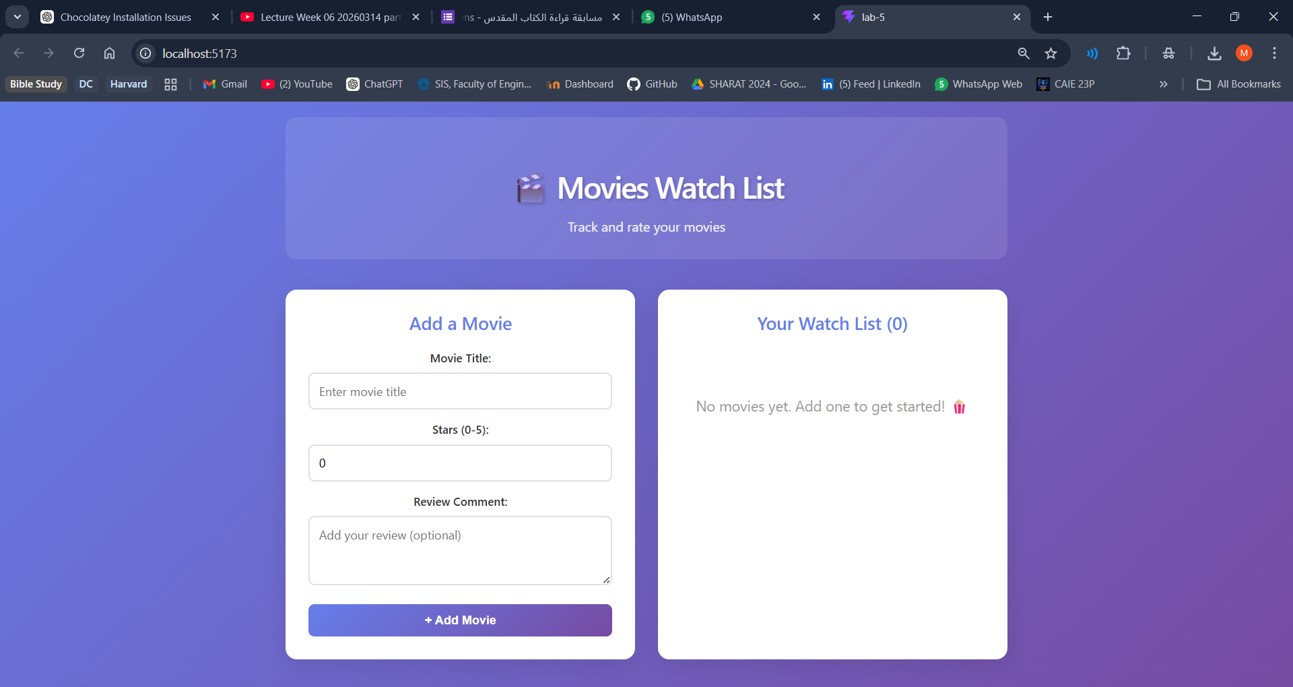

Screenshot 2 – Movies Added with Ratings and Reviews
